W.M.N.K.Madushanka

2013/CS/073

13000731

Take home assignment

SCS 2111 Laboratory II

Q1

a)

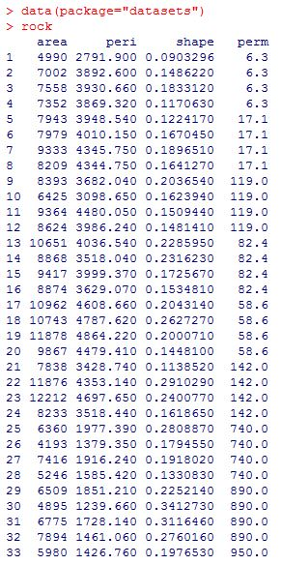

b)

Analysis for area

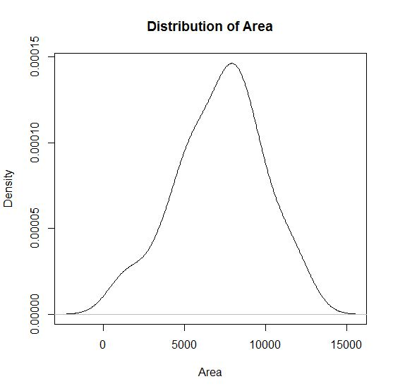

This is a normal distribution symmetric graph. Graph has reached the peak value at about 7500. Also shows the median value around 7500.

Analysis for Perimeter

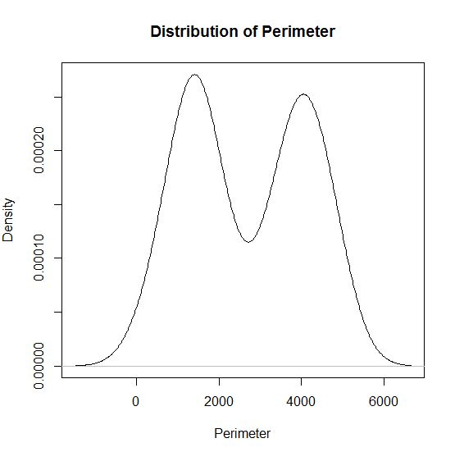

The graph is a bimodal graph. Median is around 2500. Graph has two peaks and the density of one is greater than 0.00025 and other is very close to 0.00025.

Analysis for Shape

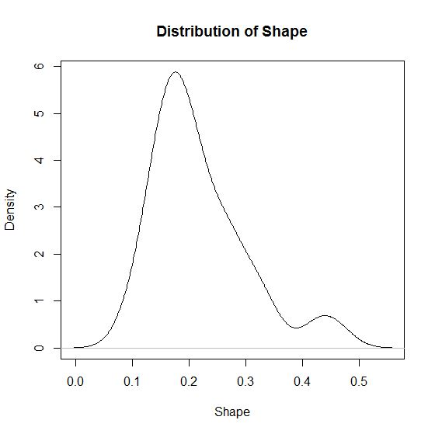

Peak value is very close to 0.2 in shape. Graph has positive skewness and has a continuous distribution. Mean value is0.21810 while median is 0.19890.

Analysis of Permeability

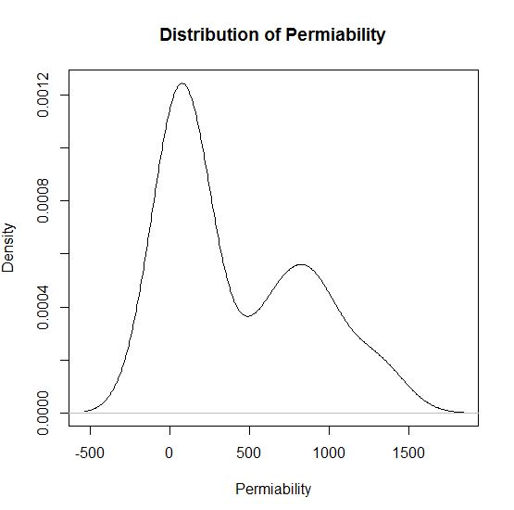

The distribution graph has a positive skewness while graph has two peaks around 100 and 800.

c)

The confidence interval is between 6428.48 and 7946.98 pixels. As the standard deviation of area distribution is 2683.849, margin of error for the variable area at 95% confidence level is 759.2513 pixels.

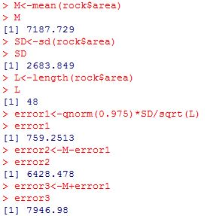

d)

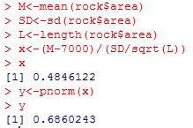

Hypothesis will not be rejected Since pnorm() is greater than 0.05.

Q2

a)

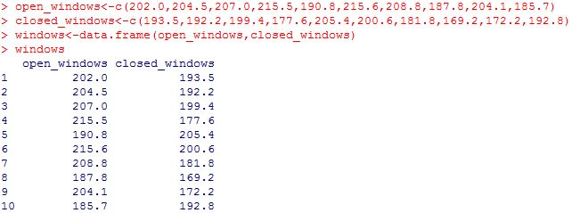

Analysis of open_windows variable

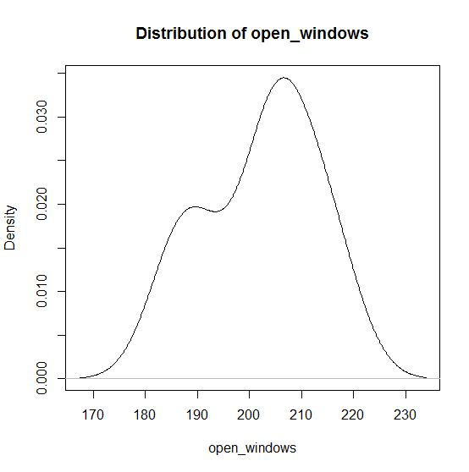

Analysis of closed_windows variable

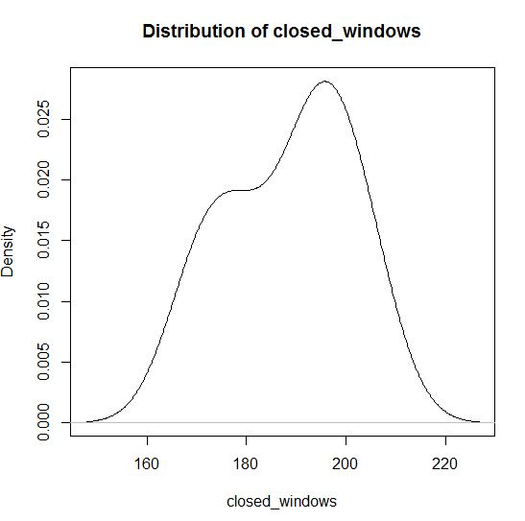

open_windows distribution variable has median value of 204.3 while for closed_windows variable distribution is 192.5. According to graphs open_windows have two mode values at values 185 and 205 nearly and closed_windows also have two mode values at 175 and 195 nearly. Both graphs are bimodal.

b)

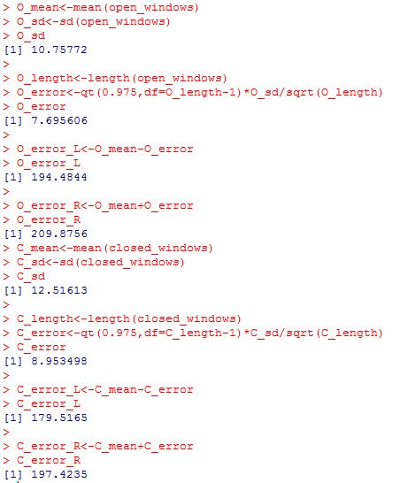

As the standard deviation of open_windows distribution is 10.76, margin of error for the variable open_windows at 95% confidence level is 7.696. The confidence interval is distributed between 194.48 and 209.87.

As the standard deviation of closed_windows distribution is 12.52, margin of error for the variable closed_windows at 95% confidence level is 8.953. The confidence interval is distributed between 179.52 and 197.42.

c)

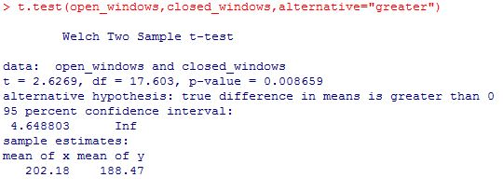

Here the p-value of the test = 0.01732 <0.05. Therefore we have to reject null hypothesis. Since we reject the hypothesis, alternative is true. That means sales on window open days is higher than in closed days. Therefore baker’s belief is true.